CS 255 Business Requirements Document

System Components and Design

Purpose

- The purpose of this project is to design a cloud-based scheduling and training system for DriverPass.
- The client, Liam (Owner of DriverPass), wants a system that allows customers to register, schedule, cancel, and modify driving appointments online.
- The system must also support internal users (IT officer, secretary) and integrate with DMV updates.

System Background

- DriverPass currently handles registration and scheduling manually via phone calls.
- The client wants to streamline operations and reduce technical overhead by moving to a web-based system.
- The system must support multiple user roles, flexible training packages, secure data collection, and DMV compliance.
- Key components include: registration module, scheduling engine, package management, test tracking, driver notes, and DMV update integration.

Objectives and Goals

- Register online and provide required personal and payment information.
- Select and schedule training packages.
- View progress on DMV practice tests.
- The system should allow staff to:
- Manage appointments and customer data.
- Track driver notes and lesson times.
- Receive DMV updates and disable packages as needed.
- Measurable goals include:
- Successful online registration and scheduling
- Secure password reset functionality
- Real-time DMV update notifications
- Accurate tracking of test status and lesson history

Requirements

Nonfunctional Requirements

Performance Requirements

- The system must run in a web-based environment accessible via browser.
- It should load pages and process requests within 2 seconds under normal conditions.
- DMV updates should be checked and processed automatically at least once per day.

Platform Constraints

- The system must run on cloud infrastructure compatible with Windows and Unix-based platforms.
- A secure relational database (e.g., MySQL or PostgreSQL) is required to store user, appointment, and test data.

Accuracy and Precision

- User roles must be distinguished by login credentials and access rights.
- Input fields should be case-sensitive where appropriate (e.g., passwords).
- The system should notify the IT officer of failed login attempts, scheduling conflicts, or DMV update errors.

Adaptability

• Packages can be disabled by the owner without code changes.
• Adding or removing packages requires developer support but should be modular for future updates.
• The IT officer must have admin-level access to modify system settings and user permissions.

Security

- Users must log in with a secure username and password.
- All data exchanges must be encrypted using HTTPS.
- Accounts should be locked after five failed login attempts to prevent brute-force attacks.
- Users must be able to reset passwords via secure email or SMS verification.

Functional Requirements

- The system shall validate user credentials when logging in.
- The system should allow customers to register with personal and payment information.
- The system shall allow customers to schedule, cancel, and modify appointments.
- The system shall allow the owner to disable training packages.
- The system shall track test progress and display status (not taken, in progress, failed, passed).
- The system should store and display driver notes including lesson time and comments.
- The system shall receive and notify staff of DMV updates.
- The system shall allow password reset via secure verification

User Interface

- The interface must be browser-accessible and mobile-friendly.
- Customer view: registration form, appointment scheduler, test progress dashboard.
- Secretary’s view: customer look-up, appointment management.
- Owner view: package control, driver notes, DMV update alerts.
- Driver view: lesson time entry and comment submission.
- The interface must be intuitive and require minimal training.

Assumptions

- All users have access to internet-connected devices.
- Customers understand basic web navigation and form entries.
- DMV provides updates in a format compatible with system integration.
- Payment processing is handled securely by a third-party service.

Limitations

- The system is not voice‑activated.
- The system will stop functioning if electricity is lost.
- The system will stop functioning if internet connectivity is lost.
- The system cannot operate without a connection to the DMV update service or central banking/payment system.
- The system will stop functioning if hosting resources or funding are depleted.

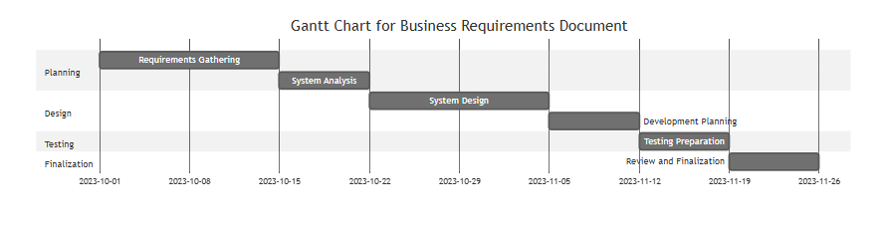
Figure 1

Figure 1: Project Timeline for DriverPass Business Requirements Document. This Gantt chart outlines the major phases of planning, design, testing, and finalization over a six-week period.

